VOCSTATS basic instructions
More detailed information on using the software can be found at:
SuperWEB documentation

Logging on:
When presented with the logon screen, please enter your details. (If you don’t have a user name or password click here).
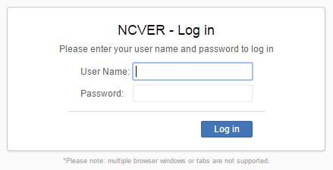

Please note that password changes are not currently supported in the software and will require you to contact the NCVER VOCSTATS administrators vocstats@ncver.edu.au to change if required.

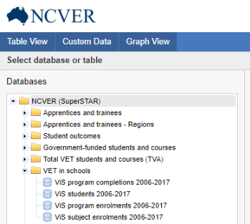
Accessing databases:
To access a database:
- Select from the list of databases available to you on the left of the VOCSTATS screen,
- Click on the arrow to Open/expand the required database folder,
- Double-click the database you would like to open. This database will be opened and folders containing the fields within this database will be displayed. You can then expand these folders by clicking once on each folder.

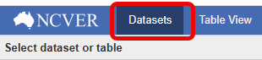
You can return to the Datasets list at any time by selecting the Datasets option to the right of the NCVER logo. If you go to the datasets list and then return to the dataset you had open your table will remain. If you open a new dataset you will lose any work that was done in the previous database. If you wish to keep previous tables, it is recommended you save them.

Adding fields:
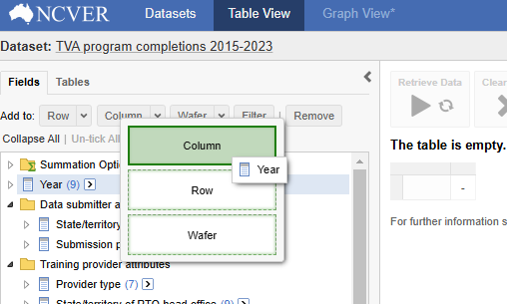
- Add a field to the table area by left mouse clicking and dragging so that the Column, Row or Wafer options become available (see right).
- Release the mouse button to drop the field in the required table area. Multiple fields can be added to each section of the table and will be sub nested under the previous field added to that section.
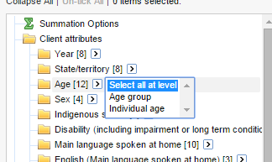
- If the field to be added to the table is a hierarchical field, you can select a different level of a hierarchy and add all the elements for that particular level (see right). For example, instead of selecting each individual age manually, select the Individual age level of the hierarchy and add to the table.

- Once a field is in the table area the Retrieve Data option will become available. Click this to populate the table. You can also drag individual fields to the Trash bin or Clear Table to remove all fields from the table area.
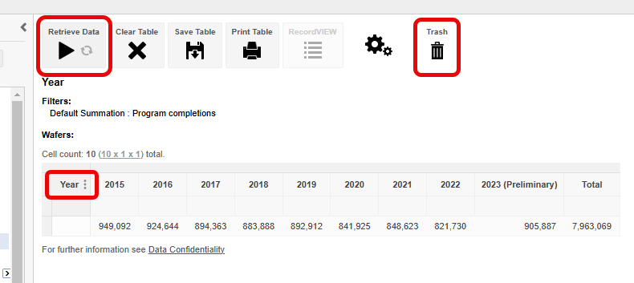
- Totals can be turned on or off using the 3 vertical dots icon to the right of the field name as highlighted above. This is available on both the horizontal and vertical axis of the table.
Removing fields:
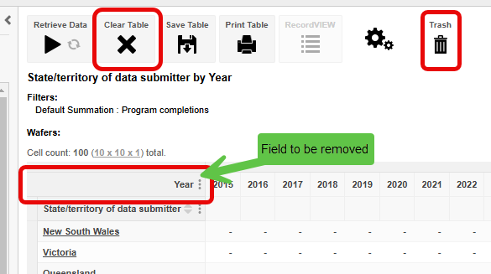
- You can remove fields from the table area by placing the mouse pointer on the field to be removed (background will change to a darker shade of grey) and dragging to the Trash bin. Alternatively, you can select Clear Table and all fields will be removed from the table area.
- Fields can also be moved within a table by placing the mouse pointer on the field to be moved and dragging to the desired location. When a field is selected it will be displayed in a darker shade of grey and can be dragged to other areas of the table which will change to a shade of green when the mouse pointer is over these.

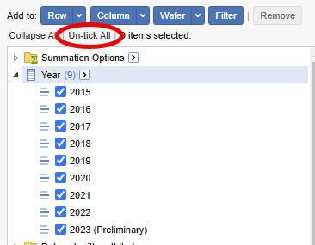
Unselecting fields:
- You can un-select elements of fields if you find you do not need them by selecting Un-tick All as shown to the right.
- To select all elements in a field you can expand a field and use the arrow button to the right of the label instead of selecting each element individually. Using this will also display a box that lists the levels of a hierarchy for the field you are looking at.
- You can select the level of the hierarchy from here or expand or close the hierarchy using the folders to the left of the field label.

Saving or downloading a table:
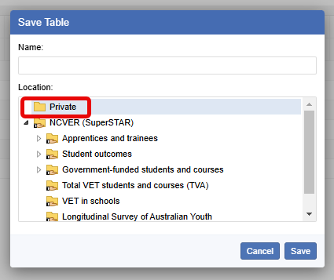
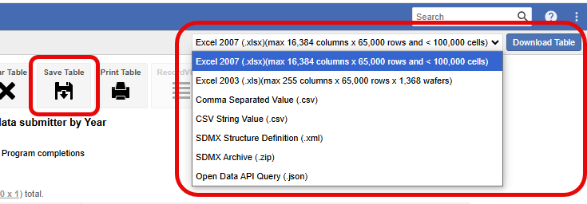
- To save a table within the VOCSTATS application select the Save Table option. A window asking where you would like to save this table will display.
- Tables saved in the Private folder will only be viewable by you.
- If you save to any of the other folders the table will be viewable by everyone who has access to VOCSTATS. The created table will only be viewable when the source database is highlighted in the Datasets list (see screenshot on next page) or from the Manage Tables option in the menu dropdown (three vertical dots) in the top right-hand corner of the application. When in the Manage Tables section you will have access to all tables created.
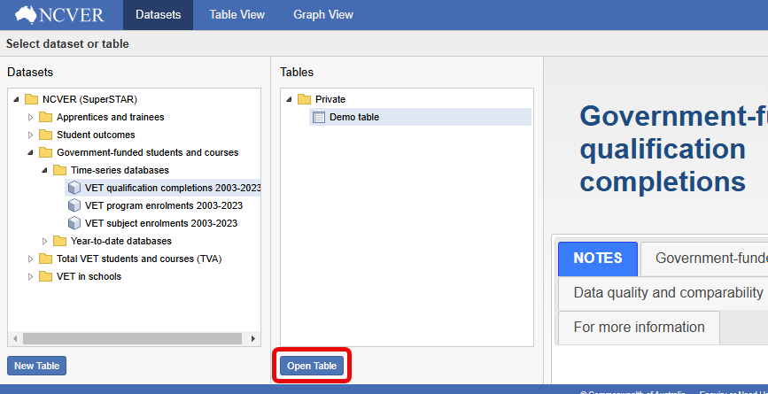
- To delete a table no longer required you need to be in the Manage Tables section. Select the tick box for the appropriate table and the Delete option will become available. Once deleted the folder structure showing the source database will also disappear.
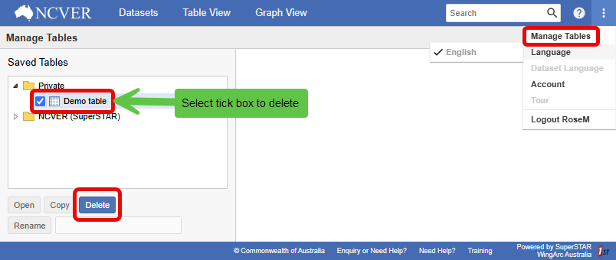
Further information:
For more detailed information on using VOCSTATS please refer to the SuperWEB documentation or contact the VOCSTATS team at vocstats@ncver.edu.au.

